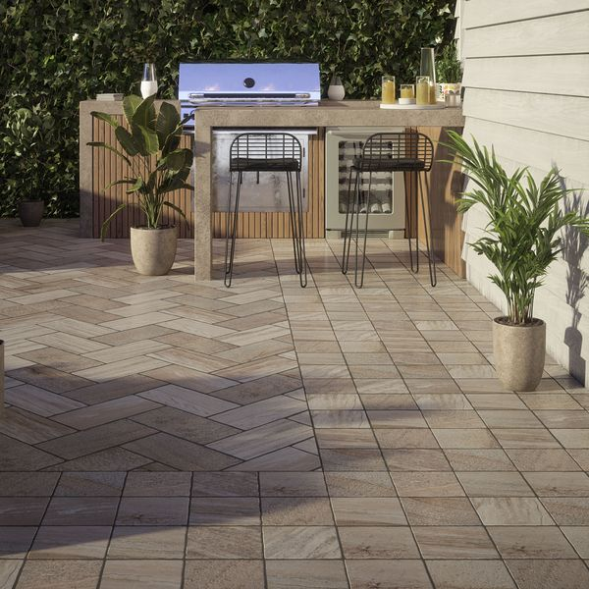**Trail Quartzita 20x20 Matt Slab Tiles:**

## **Product Description**

With a natural, timeworn appearance and a durable, easy to clean porcelain format, our Trail Quartzita collection offers the perfect look for your outdoor space. Inspired by Italian roads and pathways, our Trail Quartzita Porcelain Paving Slabs feature a realistic quartzite effect design in variegated shades of light brown and beige, perfect for emulating the rustic look of a natural cobblestone design. Designed in a small square format with a natural matt finish and an anti-slip surface, these multifunctional slabs can be used to create multiple unique patterns for a beautiful pathway or larger outdoor spaces.

Have you tried our [2](https://www.wallsandfloors.co.uk/20mm-paving-slab-trims)[0mm Paving Slab Trims?](https://www.wallsandfloors.co.uk/20mm-paving-slab-trims)

**What’s special about these tiles?**

> Inspired by Italian stone pathways

> Natural timeworn appearance

> Light brown and beige hues

> Rustic cobblestone effect design

> Opportunity for multiple layouts

## **Product INFO**

* Product ID: 44967
* Tiles Per SQM: 25
* Sale by: Per SQM
* Size: 200x200x18mm
* Weight: 1.25 KG
* Material Type: Porcelain
* Finish: Matt
* Colour: Grey
* Suitability: Floors
* Area Of Usage: Internal, External
* Rectified Edge: No
* Underfloor Heating: Yes
* Anti Slip Grade: R11 / 12 Degrees
* Document: [Cleaning & Protection Guide](https://m2.wallsandfloors.co.uk/media/amasty/amfile/attach/v6zDQ2bNO72eOYbIuSFeTd6kQ5FyNJtj.pdf),[20mm Installation Guide](https://m2.wallsandfloors.co.uk/media/amasty/amfile/attach/20mm-installation-guide_4.pdf)
* Thickness (mm): 18